Fishing in Italy (Provence of Vicenza & Veneto)

Fishing in Italy is neither expensive nor complicated. This is a brief outline of how to get started. For further details and specific information please refer to the additional handouts or contact the Fishing Information Representative, Mr. Richard Boudreau, at Caserma Ederle Outdoor Recreation at e-Mail: Richard.h.boudreau.naf@mail.mil; Alternate e-Mail: logistics-planning@hotmail.com; Phone: 646-4475 (Mornings Only); or Cell: 392-667-9336.

Ederle Outdoor Recreation can assist with the following:
(1) Rental of fishing tackle (rod, reel and small tackle box of spare hooks, etc.)
(2) Italian documents needed to obtain fishing permits
(3) Copy of latest available Province of Vicenza fishing regulation
(4) Information on local fishing venues
(5) Several deep-sea fishing trips during the fishing season
(6) Assistance in organizing group fishing events for units or other large groups
Getting Started
There are four options available for fishing in Italy:

(1) Fishing on Italian public waters
(2) Fishing on Italian private lakes and streams (concessions)
(3) Fishing in the Adriatic Sea or other saltwater options
(4) Charter fishing boats in the Adriatic
Fishing on Italian Public Waters

Fishing on Italian public waters requires a minimum of two documents: (1) Italian Fishing License, and (2) Tesserino Regionale. The Tesserino is a small booklet that is used to register the days you fish and the number of fish you catch. You can fish in all of Italy with only these two documents, however, each province is subject to their own additional requirements.

In the Vicenza province, there are 19 rivers and streams considered "Free Waters" and may be fished. The province is divided into two sections; Zone A (North) and Zone B (South), see map Attachment. Zone A requires only an Italian License and Tesserino. Zone B requires an Italian Fishing License, a Tesserino, AND a Zone B Concession permit. Fishing waters in Zone A is authorized from 7 March until 26 September 2021. Fishing waters in Zone B is open throughout the year.

To obtain an Italian Fishing License, you must access the Regione Veneto Pay Pal WEB Site: https://mypay.regione.veneto.it and follow procedures indicated below. However, to obtain a Tesserino, and a Zone B Concession Permit go to any Fishing Tackle Store (Pesca Caccia) by completing the “Vaglia” shown below.

Adults age 18 through 70 years old require a fishing license. Youth younger than the age of 18 do not require a license, but like adults, they must possess a Tesserino Regionale.

Non-Italian citizens can obtain a fishing license for €13, which is valid for 90 days. American residents with a Codice Fiscale however, may purchase a yearlong license. The yearlong license costs €34 and is valid for a full year from date of purchase, and is valid throughout Italy. Reminder, you must also purchase a “Tesserino Regionale” for €1.00.

The store owner can assist you in completing the “Vaglia” for the Zone “B” concession. Once completed, a stamped copy will be given to you, this is your permit to fish in Zone “B”. But, you must also have a Italian Fishing License.

Recommended Fishing Tackle Stores in Vicenza:

- Ruggerio Sport, Viale Della Pace 300 - 36100 Vicenza (Across from Chapel Gate of Caserma Ederle)
Nearest Tackle Shop to Caserma Ederle
(2) Bruno Sport, Viale Trento, 250, 36100 Vicenza
(3) Caccia Pesca Gasparella, Strada Sant'Antonino, 89/N, 36100 Vicenza
(4) Franco Sport Caccia Pesca, Via dal Ponte 218, 36040 Marola di Torri di Quartesolo

Note: Ensure to adhere to the boundaries of authorized fishing locations on Public Waters. Fishing in public rivers/bodies of water is only authorized in specified sections annotated in the “Aqua Liberia” (Free Water) attachment. Reference the “Aqua Libera” for outlined zones that are authorized for fishing public waters in the Vicenza Province. Additionally, unlike the United States it is illegal in Italy to fish from any bridge.

PROCEDURES FOR OBTAINING AN ITALIAN FISHING LICENSE
Starting 1 March 2021 the following procedures must be followed in order to obtain an Italian Fishing License:
STEP 1: Access the https:mypay.regione.veneto.it/pa/home.html portal.
Once in the Portal. In the Search Block: TYPE= Regione del Veneto and hit “SEARCH”
A Beneficiary Choice menu page will pop up: with “Veneto Regione “ (Click on the Coat of Arms ) and in the Body Selection block. Hit “SEARCH”
NOTE: You do not need a SPID account to make a payment; you can access payments as an Anonymous user.
This will produce a six-page list of all the places to make payments for services in the Veneto.
Scroll down until you find:
Licenza pesca dilettanistico-sportiva (validita di un anno) (Amateur-sport fishing license valid for 1 year) Euro 34,00) and the next line is,
Licenza pesca dilettanistico-sportiva per straniero (validita di tre mesi) (Amateur-sport fishing license for foreigners valid for 3 months Euro 13.00)
Decide which license you wish to purchase, click on that link and fill in blocks (they are in English)
NOTE: If you are going to be in Italy for at least a year, I suggest obtaining the annual license (less costly for the 12 month period). Other options are a day permit, and weekly permit for when you have a guest visiting for a short time.
Give a valid e-Mail address, and an e-Mail will be sent to your address: Follow instructions on the e-Mail

Recommended Fishing Public Water (License & Permits Required)

(1) (Zone A): Brenta River in Friola, Italy

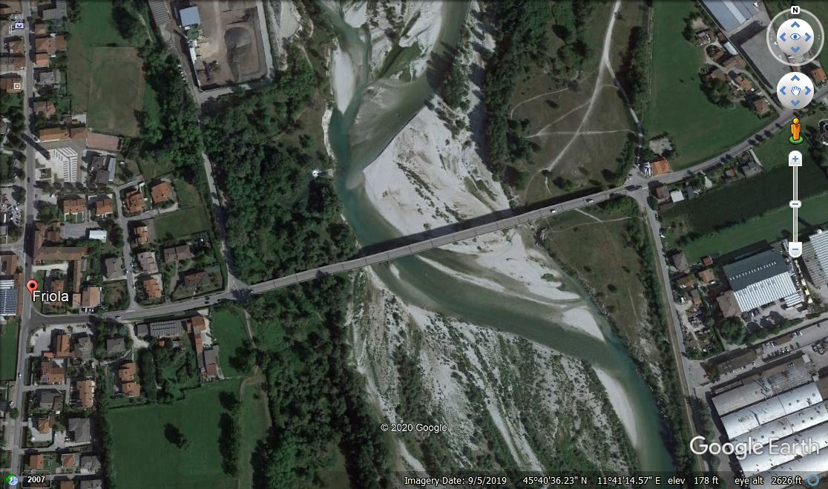
Parking

Grid Location: (45°40’36.23” N 11°41’14.57” E)
URL: https://www.google.com/maps/place/45%C2%B040'36.2%22N+11%C2%B041'14.6%22E/@45.6767306,11.6873806,17z/data=!3m1!4b1!4m5!3m4!1s0x0:0x0!8m2!3d45.6767306!4d11.6873806

(2) (Zone B): Bacchiglone River, Longare
Figure 1Grid Location (45°28’49.38” N 11°36’48.48” E)
URL: https://www.google.com/maps/place/45%C2%B028'49.4%22N+11%C2%B036'48.5%22E/@45.4803833,11.6134667,17z/data=!3m1!4b1!4m5!3m4!1s0x0:0x0!8m2!3d45.4803833!4d11.6134667

Parking
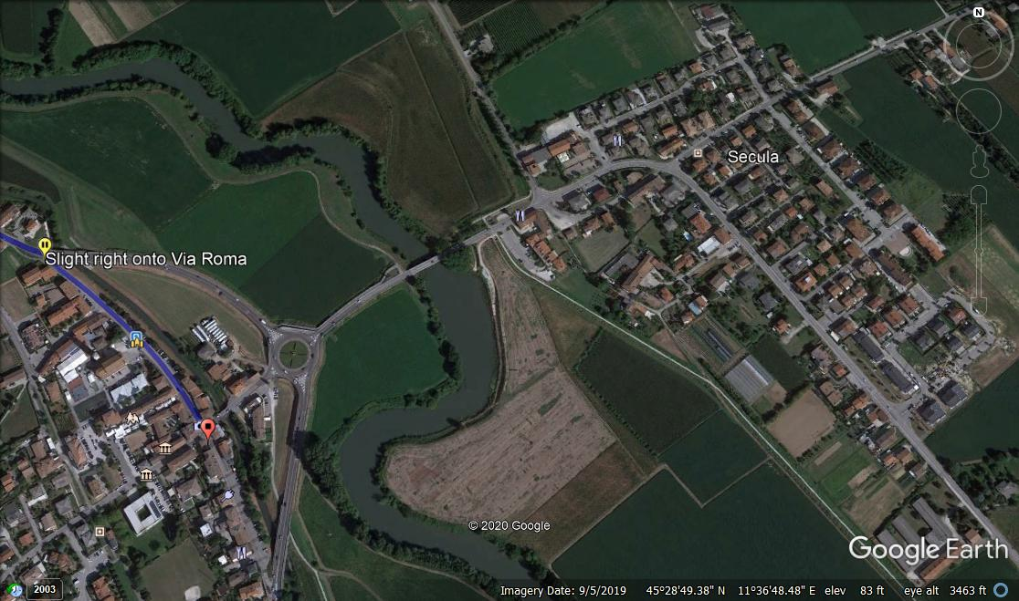

Fishing on Italian private lakes and streams (concessions)

In the Provence of Vicenza, there are five concessions that charge fees (to fish).

NOTE: These fees are paid in addition with an Italian Fishing License.
Fees are subject to change.
(1) Agno-Champo: €3 to €70 depending on age
(2) Astico Leogra: €45 to €80 depending on age
(3) Bacchiglione-astichello-tesena: €20 to €100 depending on age
(4) Bacino Acque Fiume Brenta: €20 to €120 depending on age
(5) Zone B (same aforementioned Zone B permit): includes the Bacchiglione River from Vicenza south to the town of Colze, and Lago di Fimon. Cost is €40.
Based on the above, a combination of an annual fishing license, Tesserino Regionale, and the Concession Zone B permit (total cost: €74) for a year is recommended, as it gives a fisherman the most variety of stream, river and lakes.

PRIVATE PAY OR PLAY LAKES AND PONDS

There is no fishing license required for “pay for play,” lakes/ponds. Fishermen must pay a fee to fish these waters. Most Pay for Play lakes/ponds stock various types of species such as trout, catfish, pike, perch, and bass.

Normally only Trout and Catfish can be kept and other fish are catch-and-release.

Ensure to check the specific rules at each of these locations.

There are 24 private "pay for play" lakes and ponds in the province. Prices include a membership and separate fishing fees. Membership fees run from €5 to €40 per year, and fishing fees cost between €15 and €20 per four-hour period. Some of these lakes/ponds have small bars, snack bars, or restaurants offering specialty meals.

Highlights below are a few locations, based on positive comments from individuals who have fished these locations. A complete list of all these type activities is available at Outdoor Recreation.

Recommended Pay for Play Lakes

(1) Lago Azzuro di Benetti Renzo in San Pietro Mussolino

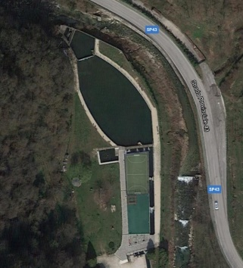

Grid Location: (45°36’05” N 11°14’32” E)
URL: https://www.google.com/maps/place/45%C2%B036'05.0%22N+11%C2%B014'32.0%22E/@45.6013889,11.2422222,761m/data=!3m1!1e3!4m5!3m4!1s0x0:0x0!8m2!3d45.6013889!4d11.2422222

Located North-West of Vicenza. Lago Azzurro is a great small lake that stocks trout and has a nice restaurant, bar, and outside park and playground for kids and families. This lake you do not have to pay to fish but must keep any/all fish (trout) caught and pay when you leave. Fee is approximately €7.50 per kilo. Additionally, for a small fee, they will clean and vacuum pack (4 to a sack) your trout. Visit their website for more information: https://lago-azzuro.it

2) Laghetto Di Fimon

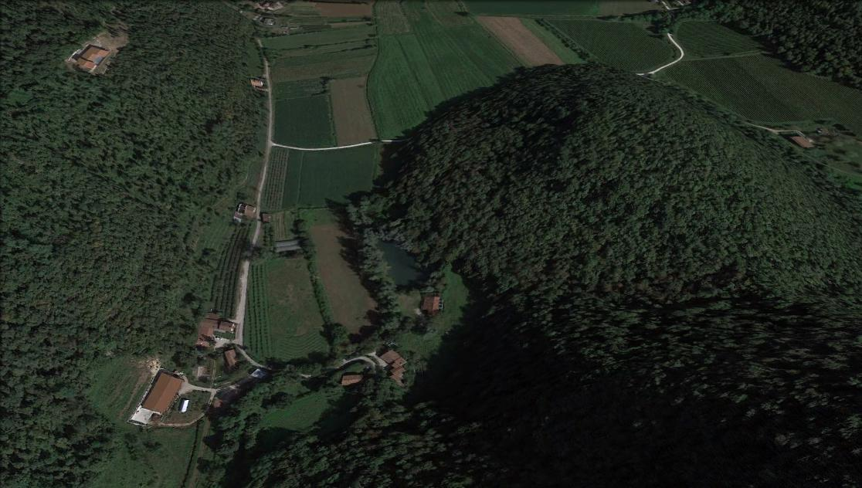
Grid Location: (45°27’26” N 11°32’30” E)
URL: https://www.google.com/maps/place/45%C2%B027'26.0%22N+11%C2%B032'30.0%22E/@45.4572222,11.5416667,763m/data=!3m1!1e3!4m5!3m4!1s0x0:0x0!8m2!3d45.4572222!4d11.5416667

This is a small pay for play lake located approximately 1.5 km south of Lago di Fimon in Arcugnano (south of Vicenza). This Lagetto is very small but is a great place to take kids; fish are easy to catch, and there is a Bird Zoo at the entrance. Any trout caught MUST BE KEPT, and you pay by the kilo for all fish caught when you leave. Fee is approximately €7.50 per kilo.

(3) Laghetto FIPSAS in San Pietro In Gu

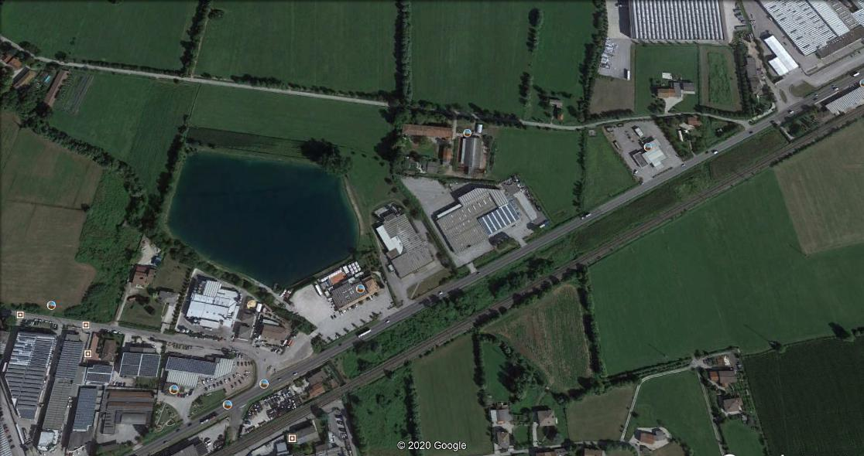
Google Maps Grid Location: (45°36’38.20” N 11°41’05.60” E) URL: https://www.google.com/maps/place/45%C2%B036'38.2%22N+11%C2%B041'05.6%22E/@45.6109134,11.6806793,14.5z/data=!4m5!3m4!1s0x0:0x0!8m2!3d45.6106111!4d11.6848889
Located off of SS53 behind the German Bar/Restaurant called Birreria der Platz. These FIPSAS Lakes stock fish (trout) regularly and everyone that uses them catch their limits normally within an hour or two. There’s an annual fee of Euro 40.00 for membership in FIPSAS (which also covers insurance) and you pay a fee to fish each time you go there, normally about 30.00 euro for a 4 hour period

(4) Laghetto Pilastroni in Dueville

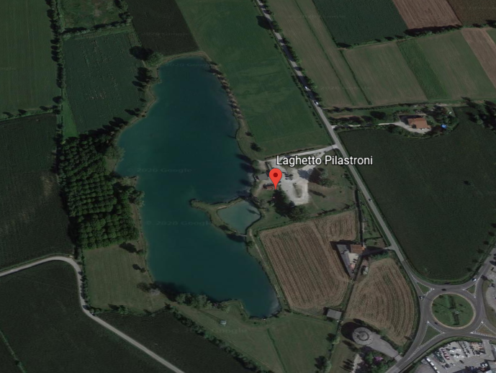
Grid Location: (45°36’45” N 11°33’32” E)
URL: https://www.google.com/maps/place/45%C2%B036'45.0%22N+11%C2%B033'32.0%22E/@45.6125,11.5588889,17z/data=!3m1!4b1!4m5!3m4!1s0x0:0x0!8m2!3d45.6125!4d11.5588889

Visit their Facebook page for more information: https://www.facebook.com/Lago-asd-Circolo-Sportivo-ai-Pilastroni-1377816912468457/

NOTE: (FIPSAS Lakes) Due to insurance requirements entrance is restricted to FIPSAS members only and no guests (whether fishing or not) are allowed (i.e., friends or family members who have not paid the 40 Euro membership fee).

Additionally, not all Pay for Play lakes are equal. Some stock only Carp and others do not restock trout frequently. We have suggested some locations that we have received good remarks from individuals that have fished them.

Fishing in the Adriatic Sea or other saltwater options (Charters)
When fishing in the Adriatic Sea in Italy there are NO licensing requirements or fees assessed. Ocean fishing is completely free in all of Europe.

CHARTER FISHING BOATS: are available for private booking for mackerel, tuna and other saltwater species. Boats range from small to large, and catamarans are also available. Larger vessels normally offer beverages and lunch or dinner depending upon the time of day the vessel is on the water. Note: Charter boats normally operate in the Spring, Summer and Fall.

Outdoor Recreation conducts Charter Boat fishing trips monthly during the Spring and Summer. Fees in 2019 were $95.00 per person and included a fishing guide, tackle, transportation to and from the Charter Boat pier, a hearty meal aboard the boat. And there are no limits on number of fish caught.
SHORELINE or SURF FISHING: Here are some recommended saltwater shoreline fishing spots: Chioggia, Sottomarina, and Bacucco (at the mouth of the Brenta River); south of Venice.

Be sure to check weather/tide conditions before going. Link: https://meteopesca.com/it/veneto/venezia

Note: excessive rain and wind will make the water too rough at the mouth of the Brenta and difficult to catch any fish. Rising tide impacts the outflow of the Brenta, making for slower moving water and better fishing opportunity.

A recommended bait/tackle shop in the Sottomarina/Chioggia area is: Tasso Esche. Address: Via Padre Emilio Venturini, 252, 30015 Chioggia VE. Website: www.tassoesche.it

Checkout the below Saltwater reference links to see Italian Fishermen catching Orata and Sarago (both are delicious to eat):
- Catching Orata (Sparus Auratus) from a boat: https://youtu.be/B25ibTvqjCw
- Catching Sarago (Dipoldus Vakgaris) from Rocks with Float & feeder: https://youtu.be/RA19IqMhSDw
- Recommended baits for Orata and Sarago: Camola di Miele, Arencola Napoletana, Granchi Vivi, Tremolina and Bibi

COPIES OF THE PESCA 2021 Provence of Vicenza Fishing Rules and Regulations are available in the Outdoor Recreation
CAUTION: Read and understand the rules in the latest fishing information booklet (Pesca 2021) to understand and comply with legal fish and limits, fishing times, catch and release, types of bait (or lures) authorized, and any prohibited practices.

Fishermen caught violating these rules/laws can receive fines and in some cases confiscation of tackle or other gear.

NOTE; If in doubt, ask the manager of one of the fishing tackle stores for assistance in understanding specific rules, and limits.

This document was prepared in corroboration between Richard H. Boudreau, Jr, Outdoor Recreation, Vicenza FMWR and Captain Ryan Spinuzzi-Nichols, 173rh Airborne Brigade, Vicenza, Italy

